**Analysis of Indian Restaurants in New York**

**Report**

**Introduction:**

New York City's demographics show that it is a large and ethnically diverse metropolis. It is the largest city in the United States with a long history of international immigration. New York City was home to nearly 8.5 million people in 2014, accounting for over 40% of the population of New York State.

Indians in the New York City metropolitan region constitute one of the largest and fastest growing ethnicities in the [New York City metropolitan area](https://en.wikipedia.org/wiki/New_York_City_metropolitan_area). The New York City region is home to the largest [Indian American population among metropolitan areas](https://en.wikipedia.org/wiki/Indian_American#Demographics) by a significant margin.

Due to large number of Indians in the city, Indian cuisine is very popular in and around New York. The growth in the New York City metropolitan region's Indian populace has been accompanied by growth in the number of Indian restaurants, located both within and outside of traditional Indian enclaves, such that within New York City proper alone, there are hundreds of Indian restaurants.

**Problem Definition:**

Looking at all these Indian restaurants we can perform data analysis on them in the following way:-

* Visualize all the parts of New York City that have Indian restaurants.
* Top ranked Indian restaurants in New York City.
* Which areas have best Indian restaurants?
* Which areas lack good Indian restaurants?
* Which all areas have potential Indian restaurant market?
* Which areas are suitable for living if one prefers Indian cuisine?

**Data:**

Following data will be used for this Data Analysis Capstone Project:

* New York City data that contains list Boroughs, Neighbourhoods along with their latitude and longitude.
  + Data source : <https://cocl.us/new_york_dataset>
  + Description: This data set contains the required information. And we will use this data set to explore various neighbourhoods of New York City.
* Indian restaurants in each neighbourhood of New York City
  + Data source : Foursquare API
  + Description: By using this API we will get all the venues in each neighbourhood. We can filter these venues to get only Indian restaurants.
* GeoSpace data
  + Data source : <https://data.cityofnewyork.us/City-Government/BoroughBoundaries/tqmj-j8zm>
  + Description: By using this geo space data we will get the New York Borough boundaries that will help us visualize choropleth map.

**Methodology:**

Following steps were followed:-

**1**. First we import New York City Data that contains list of Boroughs, Neighbourhoods along with their latitude and longitude from <https://cocl.us/new_york_dataset> and populate data into a pandas dataframe.

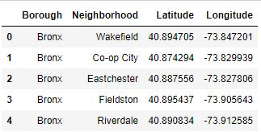

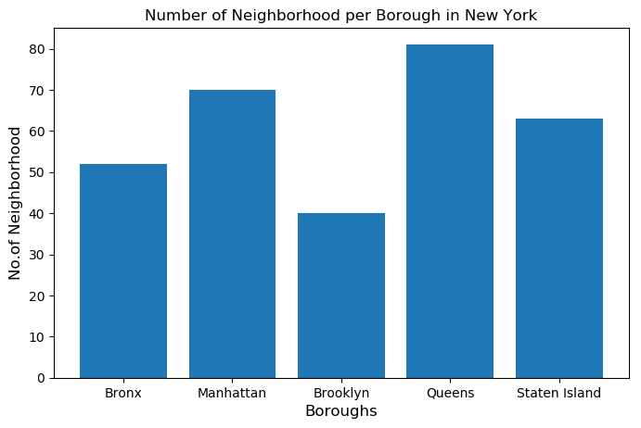

**2**. Using the latitude and longitude, we find venues for each Neighborhood via Foursquare API.

**3**. Then we filter out all the Indian Restaurants.

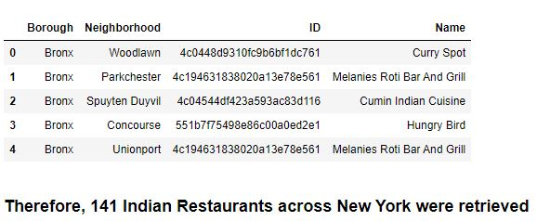

**4**. Next we retrieve information - Ratings, Likes, Tips for each Indian Restaurant, again by using Foursquare API.

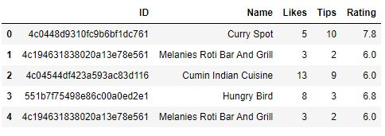

**5**. Perform analysis on the data obtained.

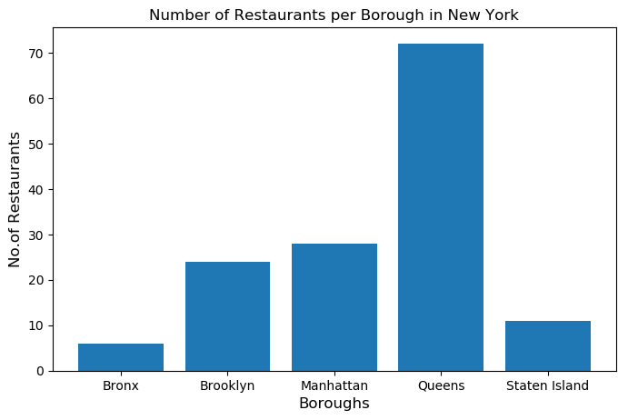

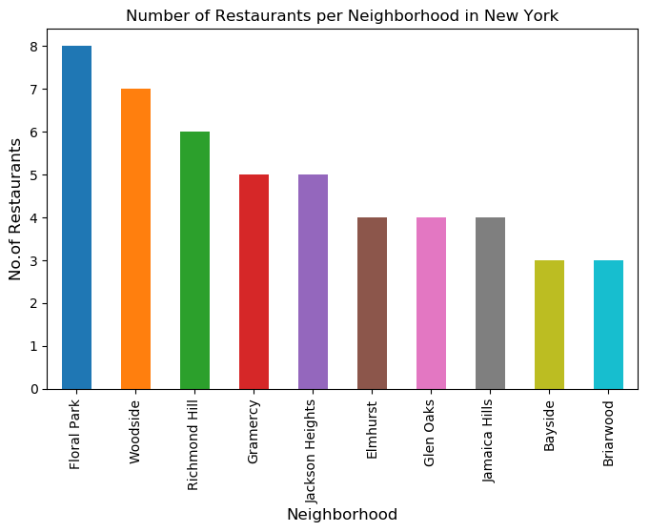

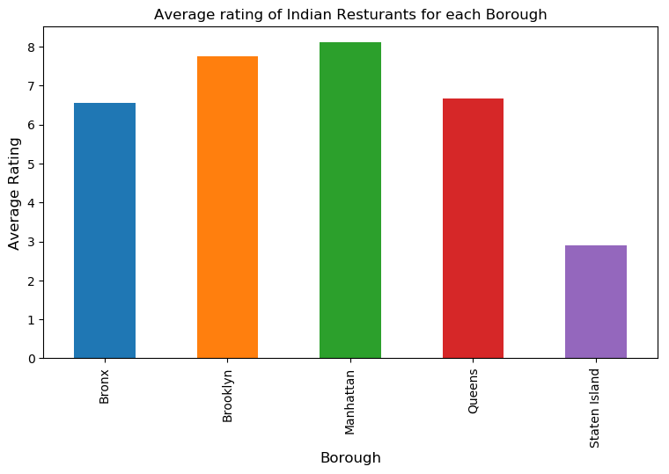

**6**. Visualize the conclusions on the map of New York.

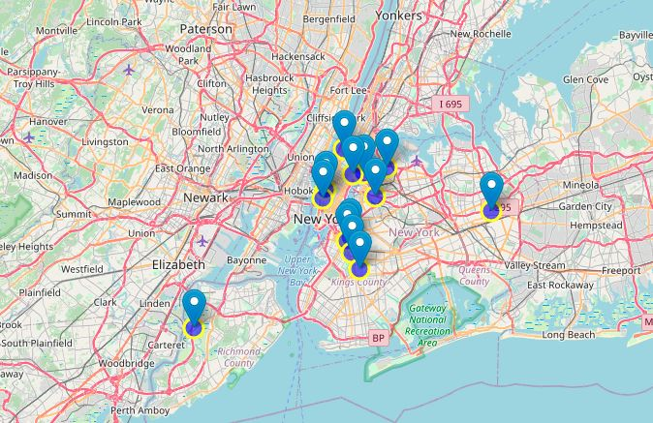

Neighborhoods with best Average Ratings >= 8.5

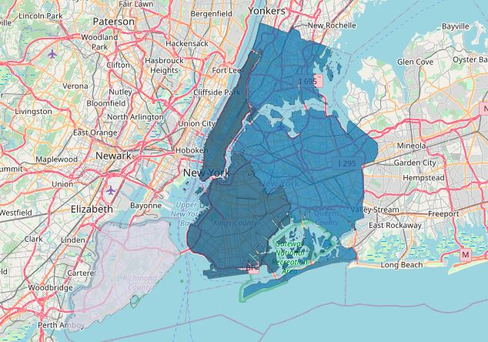

Boroughs based on Average Ratings

**Results:**

Now, with all the analysis done, we found answers to all the questions below:-

1. Which areas have best Indian restaurants? - Astoria (Queens), Blissville (Queens), Chelsea (Manhattan) are some of the best Neighborhoods with Indian Restaurants

2. Top ranked Indian restaurants in New York City are Seva Indian Cuisine (Rating-9.0), Dhaba (Tips-164, Likes-497).

3. Which areas are suitable for living if one prefers Indian cuisine? - Manhattan is the suitable place to stay if one prefers Indian cuisine since the average rating of Restaurants in Manhattan is the highest (8.0).

4. Which areas lack good Indian restaurants - Staten Island (least Indian Restaurants - 3).

5. Which all areas have potential Indian Restaurant market - Manhattan & Brooklyn have potential Indian Restaurant market.

**Conclusion:**

Hence, in this Capstone Project, I performed an analysis on Indian Restaurants in New York City with the help of visualizations such as bar graphs and maps using Foursquare API thereby discovering some useful information from the data.